03 详细设计
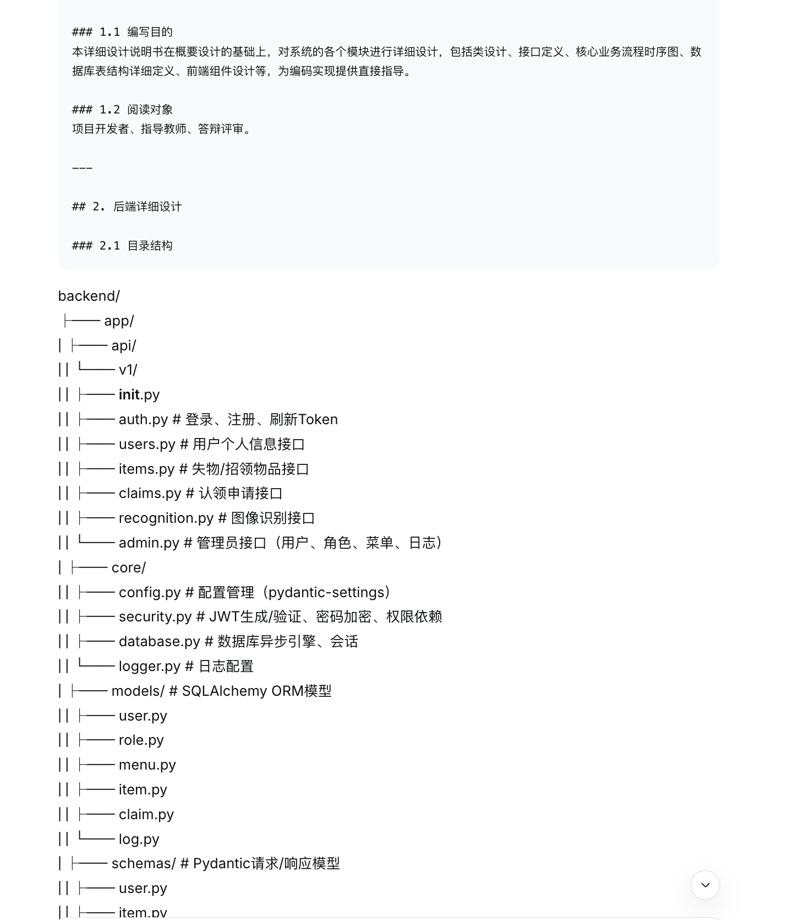
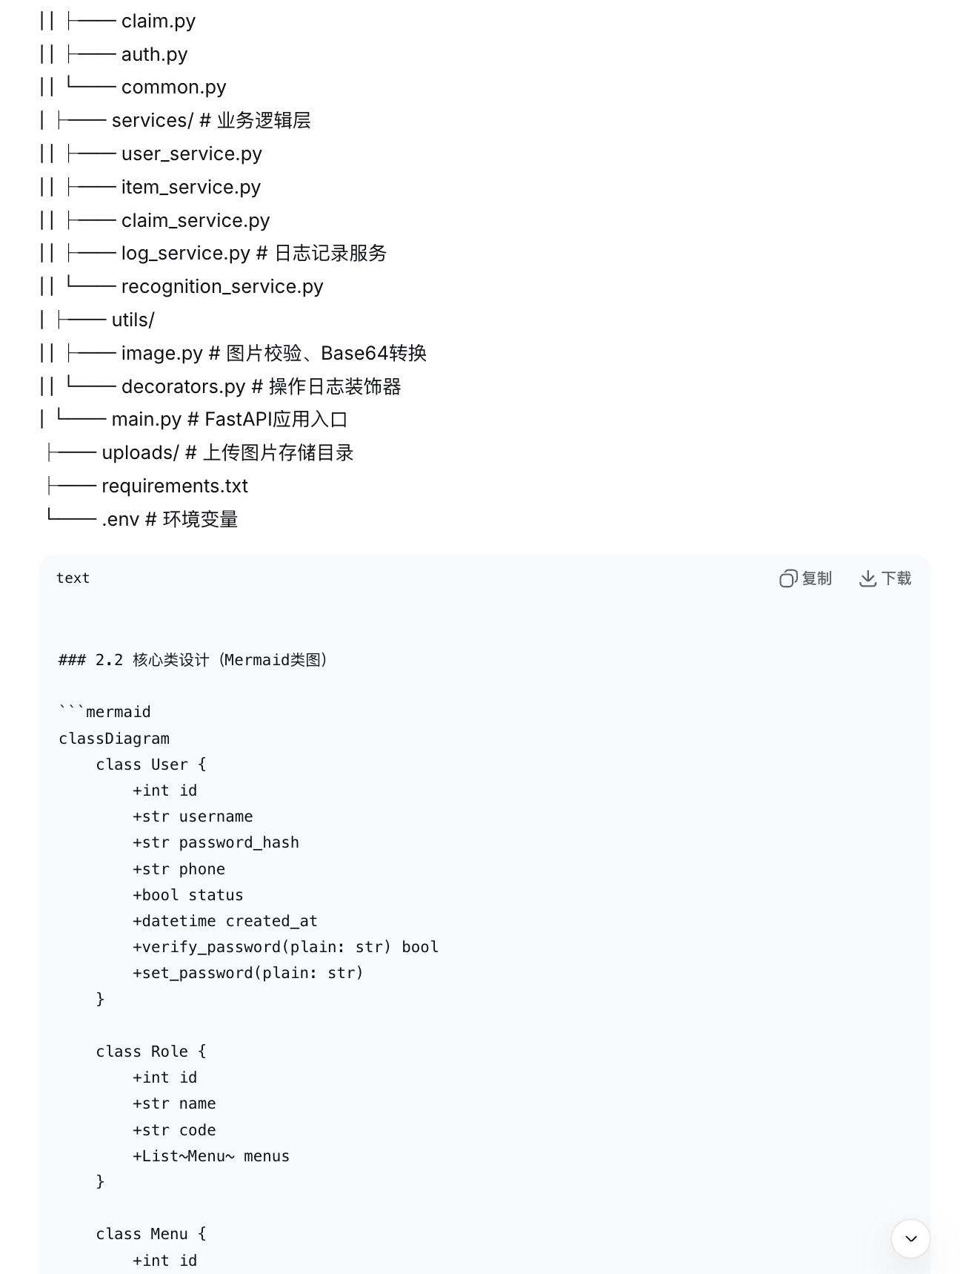
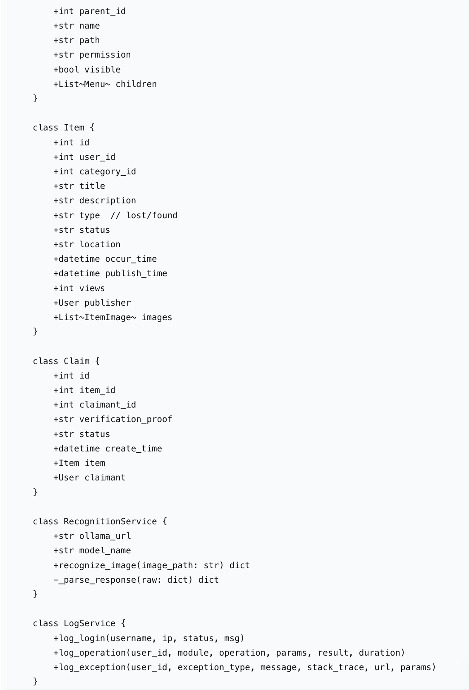
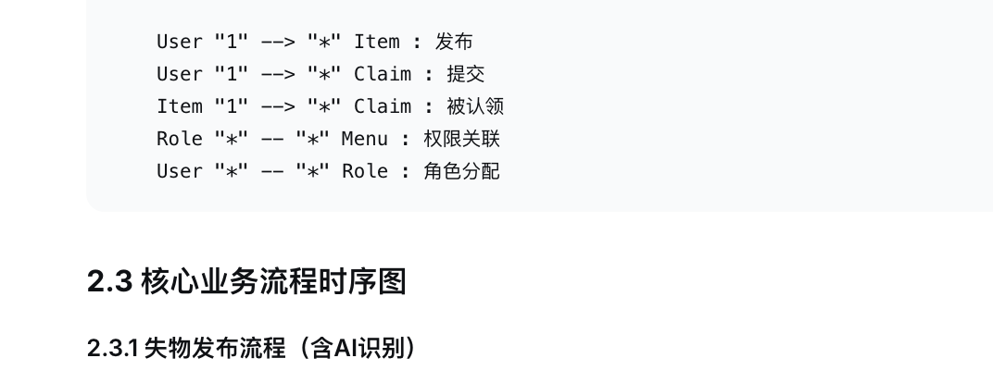
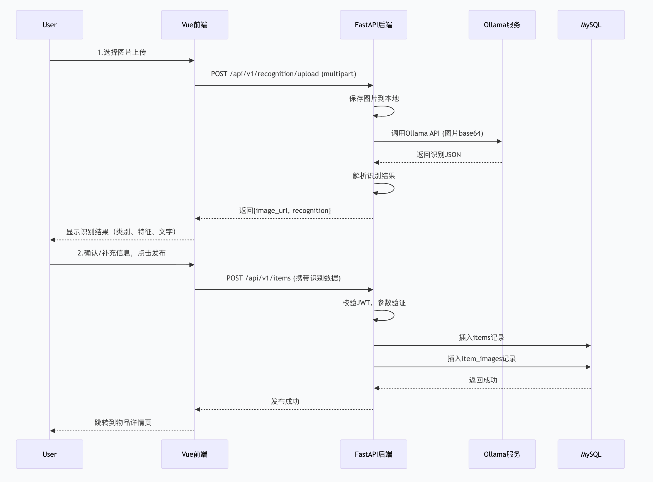

2.3.2 认领申请与验证流程

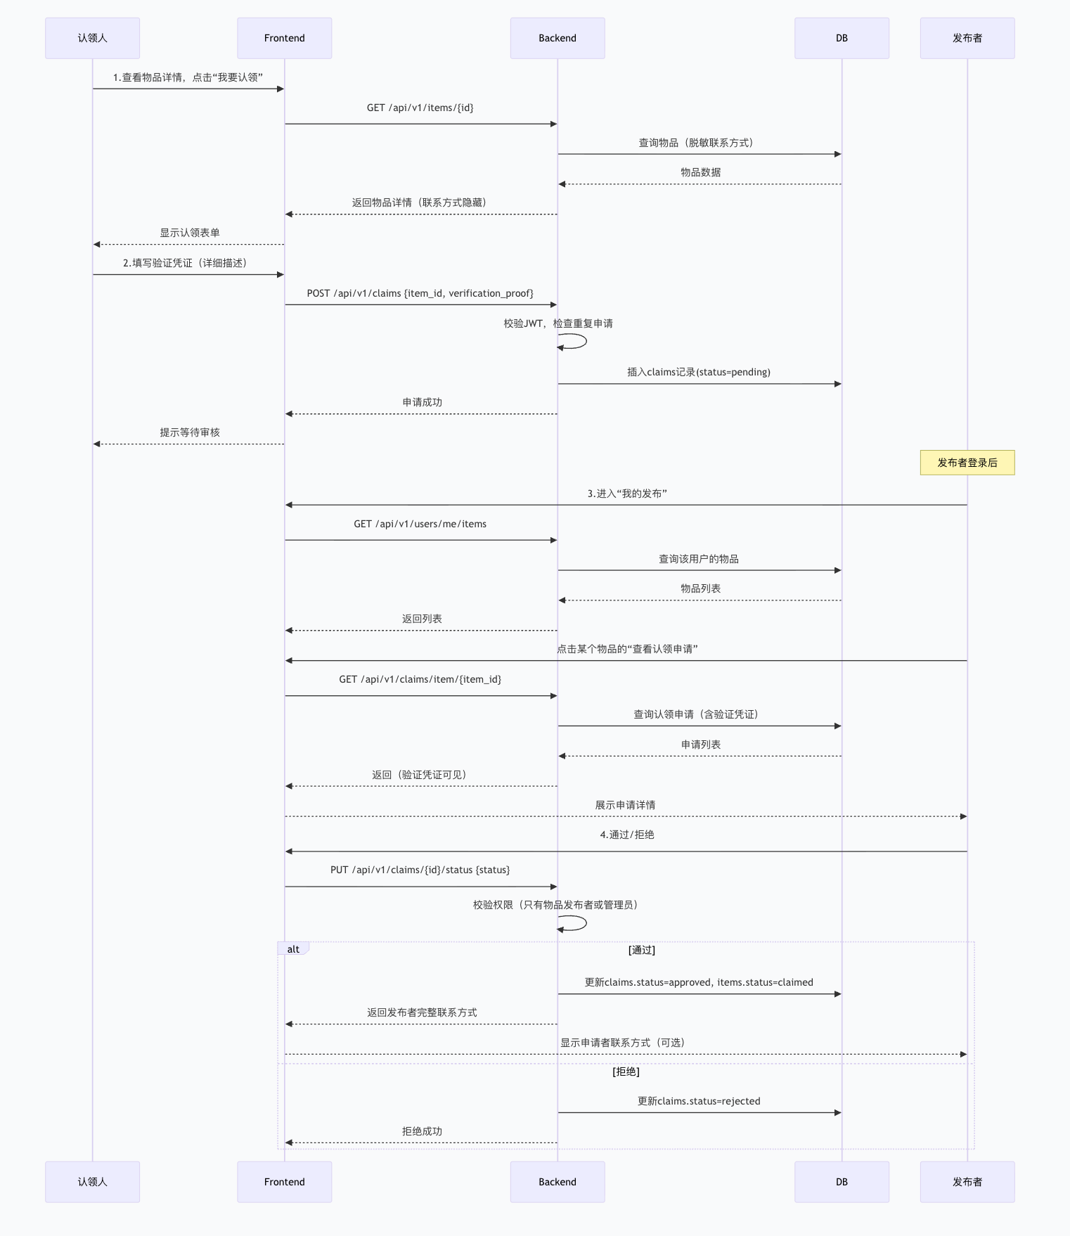

2.4 API接口详细定义（示例）

2.4.1 物品列表查询
URL:GET /api/v1/items
Query参数:
参数 | 类型 | 必填 | 说明
keyword | string | 否 | 标题/描述关键词
category_id | int | 否 | 分类ID
type | string | 否 | lost / found
status | string | 否 | pending / claimed
page | int | 否 | 页码，默认1
page_size | int | 否 | 每页条数，默认10

响应示例:
json
{ "code": 200, "data": { "total": 35, "items": [ { "id": 101, "title": "黑色双肩包", "type": "lost", "status": "pending", "location": "二食堂", "publish_time": "2026-04-18T10:30:00", "image_url": "/uploads/20260418/abc123.jpg", "publisher_phone": "138****1234" } ] }}

2.4.2 图像识别接口
URL:POST /api/v1/recognition/upload
Content-Type: multipart/form-data
参数:file(图片文件）
响应示例:
json
{ "code": 200, "data": { "image_url": "/uploads/20260419/def456.jpg", "recognition": { "category": "水杯", "features": "白色陶瓷杯，杯身印有学校Logo", "text": "XX大学", "confidence": 0.92 } }}

2.5 数据库详细表结构（SQL DDL摘要）

users 表
sql
CREATE TABLE users ( id INT PRIMARY KEY AUTO_INCREMENT, username VARCHAR(50) NOT NULL UNIQUE, password_hash VARCHAR(255) NOT NULL, real_name VARCHAR(50), student_id VARCHAR(20), phone VARCHAR(20), email VARCHAR(100), avatar_url VARCHAR(255), status TINYINT DEFAULT 1, created_at DATETIME DEFAULT CURRENT_TIMESTAMP, updated_at DATETIME DEFAULT CURRENT_TIMESTAMP ON UPDATE, is_deleted TINYINT DEFAULT 0);

items 表
sql
CREATE TABLE items ( id INT PRIMARY KEY AUTO_INCREMENT, title VARCHAR(200) NOT NULL, description TEXT, category_id INT, type ENUM('lost','found') NOT NULL, status ENUM('pending','matched','claimed','expired') DEFAULT 'pending', location VARCHAR(200), occur_time DATETIME, publish_time DATETIME DEFAULT CURRENT_TIMESTAMP, user_id INT NOT NULL, views INT DEFAULT 0, FOREIGN KEY (category_id) REFERENCES categories(id), FOREIGN KEY (user_id) REFERENCES users(id), INDEX idx_type_status (type, status), INDEX idx_publish_time (publish_time));

operation_logs 表
sql
CREATE TABLE operation_logs ( id BIGINT PRIMARY KEY AUTO_INCREMENT, user_id INT, username VARCHAR(50), module VARCHAR(50), operation VARCHAR(50), url VARCHAR(200), method VARCHAR(10), params TEXT, result VARCHAR(50), duration INT, ip VARCHAR(50), create_time DATETIME DEFAULT CURRENT_TIMESTAMP, INDEX idx_user_id (user_id), INDEX idx_create_time (create_time));

2.6 权限控制实现（RBAC）
权限检查装饰器示例（Python）：
python
from functools import wrapsfrom fastapi import Depends, HTTPExceptionfrom app.core.security import get_current_userdef require_permission(permission: str): def decorator(func): @wraps(func) async def wrapper(*args, current_user = Depends(get_current_user), **kwargs): if not current_user.has_permission(permission): raise HTTPException(status_code=403, detail="无权限访问") return await func(*args, **kwargs) return wrapper return decorator
使用示例：
python
@router.get("/admin/users")@require_permission("sys:user:list")async def get_users(...): ...

3. 前端详细设计

3.1 目录结构
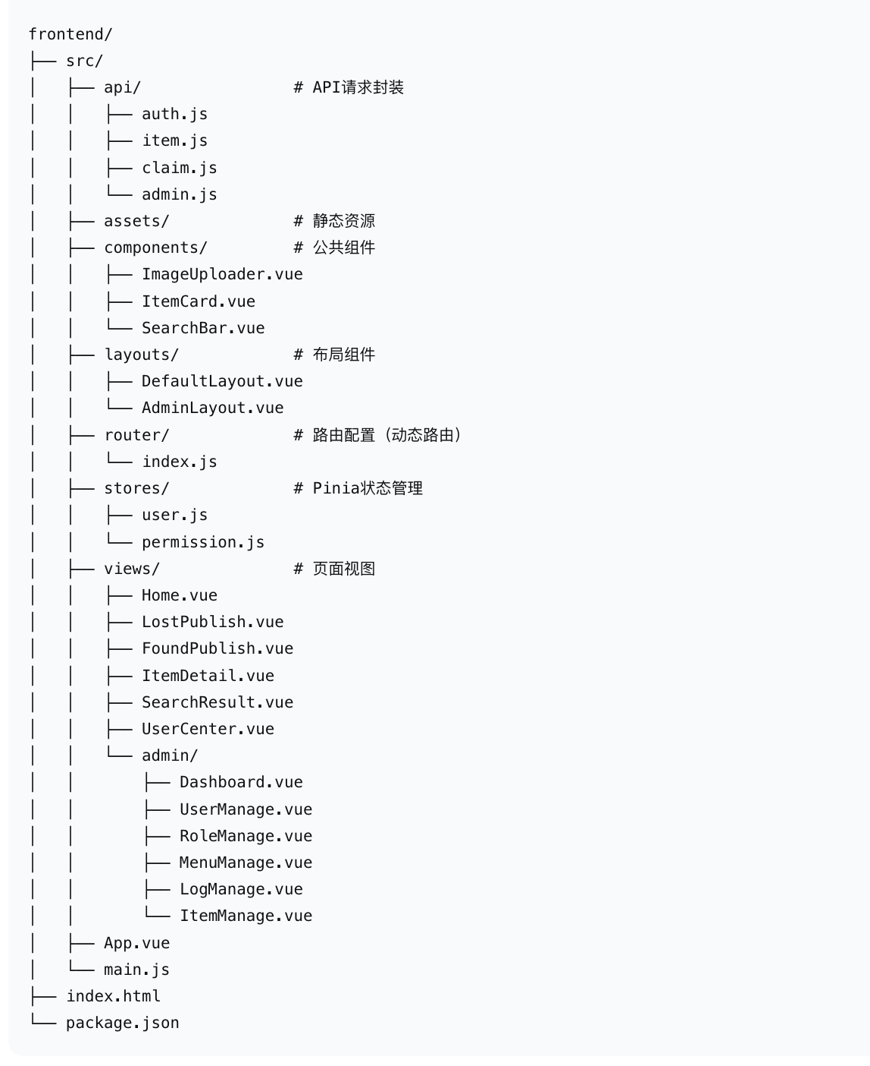

3.2 动态路由实现（Mermaid）

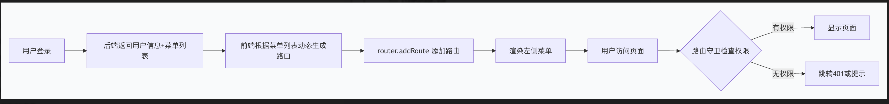

3.3 核心组件设计：ImageUploader
功能：图片上传 + AI识别结果回调
Props：
onRecognitionComplete: Function 识别完成回调
Events：
upload-success: 上传成功
recognition-success: 识别成功
模板结构（伪代码）：
html
<template> <el-upload drag :http-request="customUpload" :before-upload="beforeUpload" > <div v-if="!imageUrl">上传区域</div> <div v-else>图片预览 + 重新上传按钮</div> </el-upload> <div v-if="result" class="recognition-result"> <p>类别：{{ result.category }}</p> <p>特征：{{ result.features }}</p> </div></template>

3.4 状态管理（Pinia Store）
user store：
javascript
// stores/user.jsexport const useUserStore = defineStore('user', { state: () => ({ token: '', userInfo: null, menus: [] }), actions: { async login(username, password) { ... }, async logout() { ... }, async getMenus() { ... } }}

4. AI识别服务详细设计

4.1 Ollama调用封装（recognition_service.py）
python
import aiohttpimport base64import jsonclass RecognitionService: def __init__(self): self.ollama_url = "http://localhost:11434" self.model = "qwen2.5-vl:7b" async def recognize(self, image_path: str) -> dict: # 读取图片并转为base64 with open(image_path, "rb") as f: img_base64 = base64.b64encode(f.read()).decode() prompt = """请分析这张校园失物图片，返回JSON格式： {"category":"物品类别","features":"详细特征","text":"图中文字","confidence":0.95} """ async with aiohttp.ClientSession() as session: payload = { "model": self.model, "prompt": prompt, "images": [img_base64], "stream": False, "format": "json" } async with session.post(f"{self.ollama_url}/api/generate", json=payload) as resp: result = await resp.json() return json.loads(result["response"])

4.2 识别接口路由
python
@router.post("/recognition/upload")async def recognize_upload(file: UploadFile = File(...)): # 1. 保存文件 file_path = await save_upload_file(file) # 2. 调用识别服务 recog = RecognitionService() result = await recog.recognize(file_path) # 3. 返回 return {"image_url": get_url(file_path), "recognition": result}

5. 日志详细设计

5.1 操作日志记录装饰器
python
# utils/decorators.pyfrom functools import wrapsimport timedef log_operation(module: str): def decorator(func): @wraps(func) async def wrapper(*args, **kwargs): start = time.time() try: result = await func(*args, **kwargs) duration = int((time.time() - start) * 1000) # 异步记录操作日志 await LogService.log_operation( user_id=current_user.id, module=module, operation=func.__name__, params=kwargs, result="success", duration=duration ) return result except Exception as e: # 记录失败日志 await LogService.log_operation(..., result="failed") raise return wrapper return decorator

5.2 日志查询接口
python
@router.get("/admin/logs/operation")async def get_operation_logs( page: int = 1, page_size: int = 20, username: str = None, module: str = None, start_time: datetime = None, end_time: datetime = None, current_user: User = Depends(require_permission("sys:log:list"))): query = OperationLog.query if username: query = query.filter(OperationLog.username.like(f"%{username}%")) # ... 其他过滤 paginated = await paginate(query, page, page_size) return {"total": paginated.total, "logs": paginated.items}

6. 安全设计要点
安全项 | 实现方法
密码存储 | bcrypt哈希，加盐
传输安全 | HTTPS（生产环境）
JWT过期 | 24小时过期，支持刷新Token
防SQL注入 | SQLAlchemy ORM参数化查询
文件上传 | 白名单（jpg/png），大小限制（10MB），UUID重命名
敏感信息脱敏 | 手机号显示138****0000，联系方式仅认领通过后可见
XSS防护 | 前端Vue自动转义，后端对输出不信任

7. 部署与运行说明

7.1 开发环境运行
后端：
cd backendpip install -r requirements.txtuvicorn app.main:app --reload --port 8000
前端：
cd frontendnpm installnpm run dev
Ollama：
ollama pull qwen2.5-vl:7bollama serve

7.2 生产环境构建
# 前端构建npm run build # 生成dist目录# 后端使用gunicorn/uvicornuvicorn app.main:app --host 0.0.0.0 --port 8000 --workers 4

